LET’S PLAY SOME WATER (NOT SO) FUN GAME!

Problem:
We study a simple game consisting in a grid of tiles, separated or not by walls, forming different groups of tiles. Numbers figure on the end of some lines/columns. They correspond to a number of flood tiles in this column/line. The goal of the game is to find a solution, consisting of a combination of tiles flooded satisfying the number on each end of line/column and natural rules of physic.
R_side_numbers:
-Each line/column must contain the exact number of flooded tiles indicated on the end of the said line/column.
-Water must follow the following rules:
R_water_down:
A tile without water cannot be under a tile of water if there is no wall to stop said water.
R_water_level:
In the same group of tiles, if the group contains water, the level must be the same in all the group even if it is U shaped (or n shaped, for “simplicity”).

Modelling:
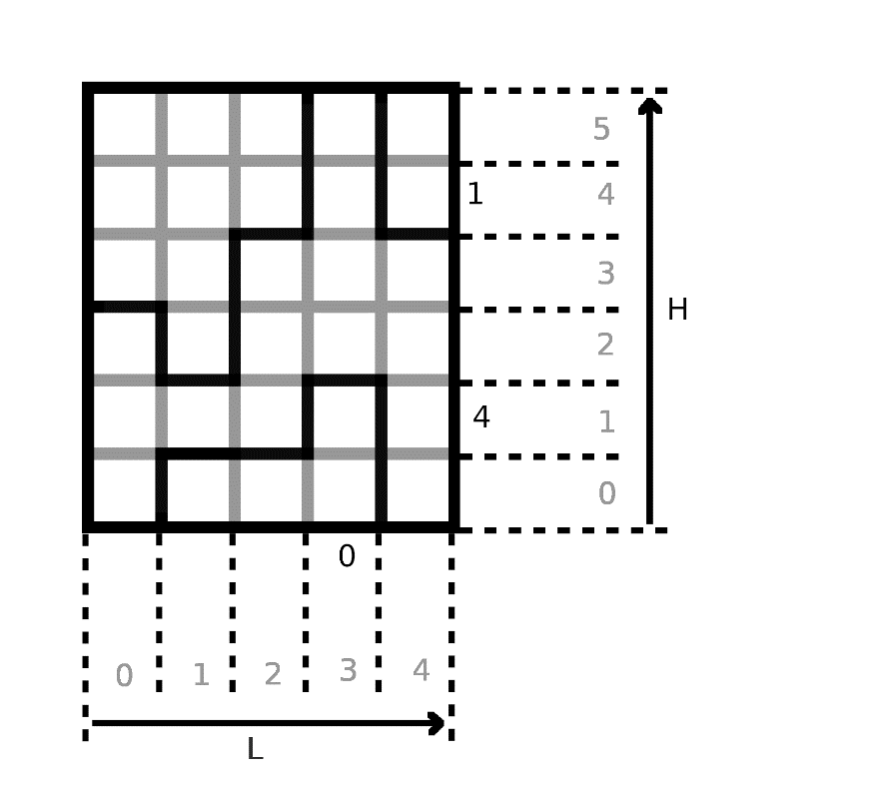
Ih0.3
Iv1.1
a1.3

Definitions:
Let L being the horizontal size of the grid.
Let H being the vertical size of the grid.

∀0≤i<L,0≤j<H we name ai,j the tile of coordinates i,j
∀0<i<L,0≤j<H we name Ivi,j the (vertical) intersection of the tiles ai,j and ai-1,j
∀0≤i<L,0<j<H we name Ihi,j the (horizontal) intersection of the tiles ai,j and ai,j-1
∀0≤i<L we name Zci the number aside to the column i.
∀0<j<H we name Zlj the number aside to the line j.

∀i,j, Wi,j = 1 <=> water in ai,j.
∀i,j, Bhi,j = 1 <=> horizontal barrier at Ihi,j
∀i,j, Bvi,j = 1 <=> vertical barrier at Ivi,j

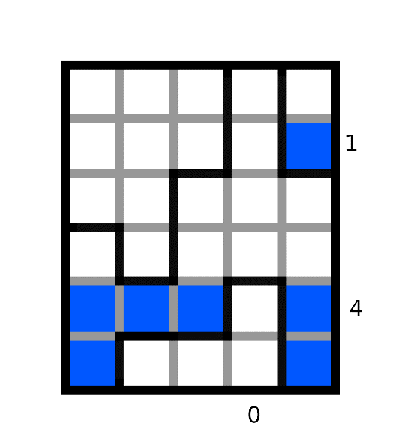
Bv1.5=0
Bv2.3=1
Bh1.3=1
W0.2=0
W0.0=1
Bh1.3=1

Modelling the “water’s physics”:
[schema]

We attribute a number to each tile such that each tile inside a same group of tiles have the same value, in order to be able to say if two tiles are in the same group (i.e. if there’s a path between these tiles). For each tile ai,j, we can access this number at ai,j.val.

To attribute such values, a way to proceed is to initialize the values as the following:
∀i,j ai,j.val=j*h+i
And then use the following rule to get the same values in each group:
∀i,j ¬Bhi,j => ai,j.val = min( ai,j.val ; ai,j-1.val )
∀i,j ¬Bvi,j => ai,j.val = min( ai,j.val ; ai-1,j.val )
0
0
0
0
0
0
0
0
0
0
0
0
0
0
0
1
1
1
1
11
11
11
11
11
11
11
11
11
24
24

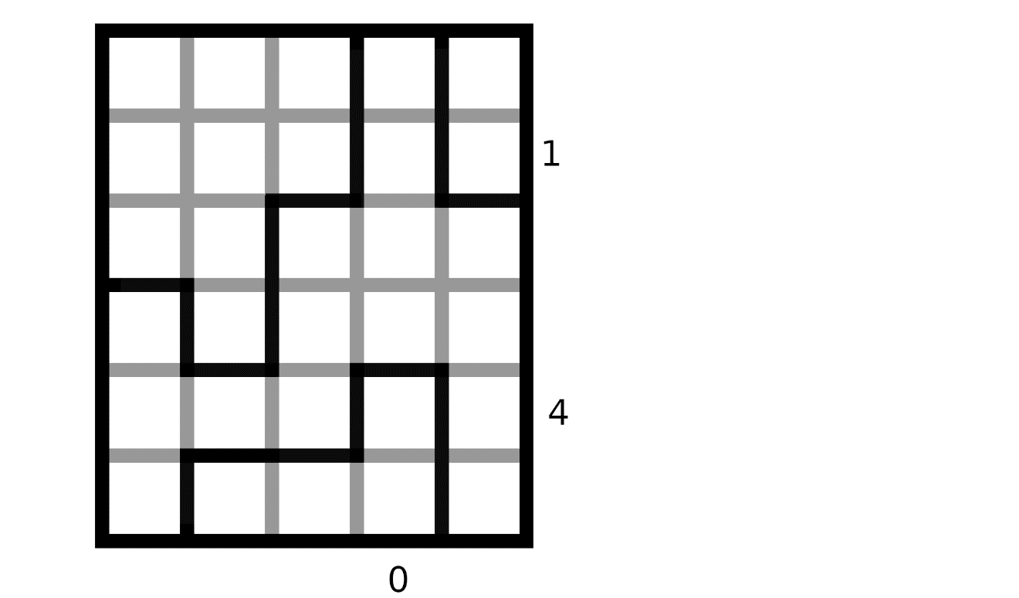

Once ai,j.val is defined, the following rules model the fact that water must follow the rules of physics:

R_water_down:
∀i in {0,…,L-1},j in {0,…,H-1}:

R_water_level
∀i1,i2 in {0,…,L-1},j in {0,…,H-1}:

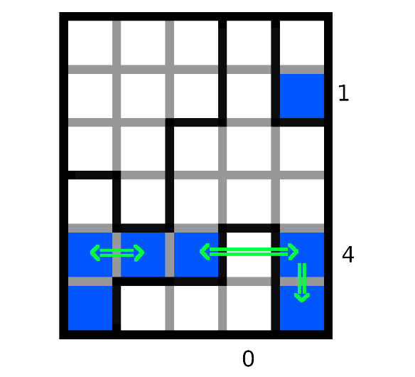

Modelling the fact that Zci and Zlj represents the number of tiles of water on the line or column (application of R_side_numbers) :
Since there happens the same thing on each line with Zli and each column with Zcj, let’s say that S is either L or H, and N is the other.

We will then define Z and Wzi as follows:
if S = H:
for any 0≤i<S, Z is Zci
for any 0≤j<N, Wzj is Wi,j (representing the fact of water being on the tiles of the same column as Z)
if S = L:
for any 0≤i<S, Z is Zli
for any 0≤j<N, Wzj is Wj,i (representing the fact of water being on the tiles of the same line as Z)

Since we want exactly Z tiles to be filled of water, a way to model it is by making a disjunction of each model, but transforming it to a conjunction normal form by developing is long and grindy. Instead, we can model the fact that any assignment with at least Z+1 tiles filled of water should be unsatisfiable, and that any assignment with at most Z-1 tiles filled of water should be unsatisfiable.

To model the fact that any assignment with at most Z-1 tiles filled of water should be unsatisfiable, we do a conjunction of all possible clauses containing exactly N-(Z-1) elements of the form Wzi. (like this, any assignment of at most Z-1 elements that are true have a clause that they can’t validate).
If Z = 0, no need to add a formula for this rule. Otherwise, the formula is the following:

(The product symbolizes a succession of conjunctions and the sum, a succession of disjunctions.)

To model the fact that any assignment with at least Z+1 tiles filled of water should be unsatisfiable, it is the same reasoning, but with a conjunction of all possible clauses containing exactly Z+1 elements of the form ¬Wzi (note the negation, and so it is the same as verifying that at most N-Z elements of the form Wzi are false, which is directly equivalent to saying that there is at most Z tiles filled)
If Z = N, no need to add a formula for this rule. Otherwise, the formula is the following:

And so, the conjunction of these two formulas models the fact that exactly Z of the Wzi are true, and the other false.

Example:
Here we take the following grid:
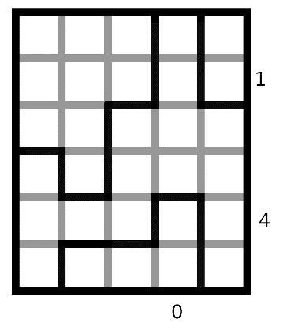
In this example we need a model satisfying all the above-mentioned rules:
R_water_down:
(¬W0.5 V W0.4)Ʌ(¬W0.4 V W0.3)Ʌ(¬W0.2 V W0.1)Ʌ(¬W0.1 V W0.0)
Ʌ(¬W1.5 V W1.4)Ʌ(¬W1.4 V W1.3)Ʌ(¬W1.3 V W1.2)
Ʌ(¬W2.5 V W2.4)Ʌ(¬W2.3 V W2.2)Ʌ(¬W2.2 V W2.1)
Ʌ(¬W3.5 V W3.4)Ʌ(¬W3.4 V W3.3)Ʌ(¬W3.3 V W3.2)Ʌ(¬W3.1 V W3.0)
Ʌ(¬W4.5 V W4.4)Ʌ(¬W4.3 V W4.2)Ʌ(¬W4.2 V W4.1)Ʌ(¬W4.1 V W4.0)

R_water_level:
( ¬W0.5 V W1.5)Ʌ(W0.5 V ¬W1.5)Ʌ( ¬W1.5 V W2.5)Ʌ(W1.5 V ¬W2.5)
Ʌ( ¬W0.4 V W1.4)Ʌ(W0.4 V ¬W1.4)Ʌ( ¬W1.4 V W2.4)Ʌ(W1.4 V ¬W2.4)
Ʌ( ¬W0.3 V W1.3)Ʌ(W0.3 V ¬W1.3)Ʌ( ¬W2.3 V W3.3)Ʌ(W2.3 V ¬W3.3)Ʌ( ¬W3.3 V W4.3)Ʌ(W3.3 V ¬W4.3)
Ʌ( ¬W2.2 V W3.2)Ʌ(W2.2 V ¬W3.2)Ʌ( ¬W3.2 V W4.2)Ʌ(W3.2 V ¬W4.2)
Ʌ( ¬W0.1 V W1.1)Ʌ(W0.1 V ¬W1.1)Ʌ( ¬W1.1 V W2.1)Ʌ(W1.1 V ¬W2.1)
Ʌ( ¬W1.0 V W2.0)Ʌ(W1.0 V ¬W2.0)Ʌ( ¬W2.0 V W3.0)Ʌ(W2.0 V ¬W3.0)

R_side_numbers:
For the line 1 (Zl1 = 4) :
S = 6, Z = Zl1= 4, N = 5
N-Z = 1
(W0,1 V W1,1)Ʌ(W0,1 V W2,1)Ʌ(W0,1 V W3,1)Ʌ(W0,1 V W4,1)
Ʌ(W1,1 V W2,1)Ʌ(W1,1 V W3,1)Ʌ(W1,1V W4,1)
Ʌ(W2,1 V W3,1)Ʌ(W2,1V W4,1)
Ʌ(W3,1V W4,1)

Ʌ (¬W0,1 V ¬W1,1 V ¬W2,1V ¬W3,1V ¬W4,1)

For the line 4 (Zl4 = 1):
S = 6, Z = Zl4= 1, N = 5
N-Z = 4
(W0,4 V W1,4 V W2,4 W3,4V W4,4)

Ʌ(¬W0,4 V ¬W1,4)Ʌ(¬W0,1 V ¬W2,4) Ʌ(¬W0,1 V ¬W3,4) Ʌ(¬W0,1 V ¬W4,4)
Ʌ(¬W1,4 V ¬W2,4) Ʌ(¬W1,1 V ¬W3,4) Ʌ(¬W1,1 V ¬W4,4)
Ʌ(¬W2,4 V ¬W3,4) Ʌ(¬W2,1 V ¬W4,4)
Ʌ(¬W3,4 V ¬W4,4)

For the column 3 (Zc3 = 0):
S = 5, Z = Zc3= 0, N = 6
N-Z = 6
¬W3,0 Ʌ ¬W3,1 Ʌ ¬W3,2 Ʌ ¬W3,3 Ʌ ¬W3,4 Ʌ ¬W3,5

